42nd Street and The Horsfall present:
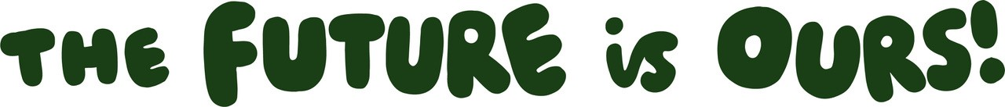
Celebrating Young People’s Creativity, Voice & Action in 2020
16 – 26 November 2020
Manchester/Online
A programme of art, performance, literature, music, activism and events by young people in Greater Manchester exploring their views and visions for the future.

The Future Is Ours festival celebrates young people’s creativity, voice and action in 2020 and features original artworks by over 130 young people shared online and on billboards and street posters across Manchester. During the festival’s ten day run 16-26 November works have been launched online and now all the artworks, interviews, video performances and literature are available to view on 42nd Street’s website.
In a year in which young people have faced some of the worst disruption and face long term impacts of the Covid-19 pandemic on their prospects, their voice and views have missing. Organised by The Horsfall and 42nd Street, The Future Is Ours showcases young people’s urgent messages for society in their own words, images and creative expression.
The works include:
- The Art Action Room – documentation of an art event by young artist Sophia who created a room to express anger, explore the effects of bullying and art’s power to heal and transform.
- Poetry and songs from the Creative Youth group expressing personal experiences and calling for mental health and education reform
- Billboards around Manchester showing artwork created by young people in individual collaboration with professional artists with messages of hope and resilience
- Video performance and street posters by Poet in Residence Shannon Westacott
- ANGERZINE art magazine by young artist Rosie Sharkey exploring young people’s anger in 2020
- Noorie’s Lightbulb, a personal zine and guide by young writer Noor Rubani sharing her journey and learnings as a British South Asian young woman
- Film of over 100 portraits created by young people across Greater Manchester during the lockdown this year
- And much more!

Young artist Millie Gater, 20, whose billboard artwork is a detailed portrait of inclusivity and female empowerment with a message of hope at this time, says: “Young people have so much to say that is worth listening to. We have fresh new ideas, building on the paths the trailblazers before us paved, and by collaborating and uplifting each other, these ideas will grow into real manifestations that will revolutionise our society, for both us now and for future generations.

“There is so much on the shoulders of young people, and we all feel that responsibility - We know that the future is ours, yet we're using the influence we have now and demanding more from those in power.”

Rosie Sharkey, 17, creator of the first ANGERZINE, says: “We are the next generation. We will have to deal with all the repercussions of the decisions older people and people in power make right now, meaning we should have a say in big and important topics that affect us and people around us. Young people are misunderstood and not seen for how intelligent we really are and the difference we can make.”

The Horsfall’s Creative Producer Rod Kippen says: “In a year where young people have been ignored, disrupted and blamed. One of the few spaces for their voice has been through creativity and art. We want to celebrate what they've created and hear what they have to say.”

